1010_CPP Enrollment initiated by EV for an Single customer Electric Meter
Contract No. 4012976394
Material No. 88000104
Serial No. 20003234
Equipment No. 100004736946
Contract Account. 100045173117
Functional Location. 6001186157

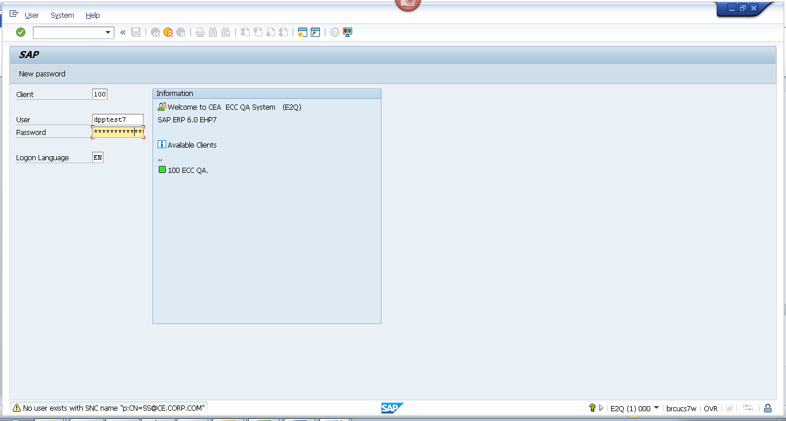
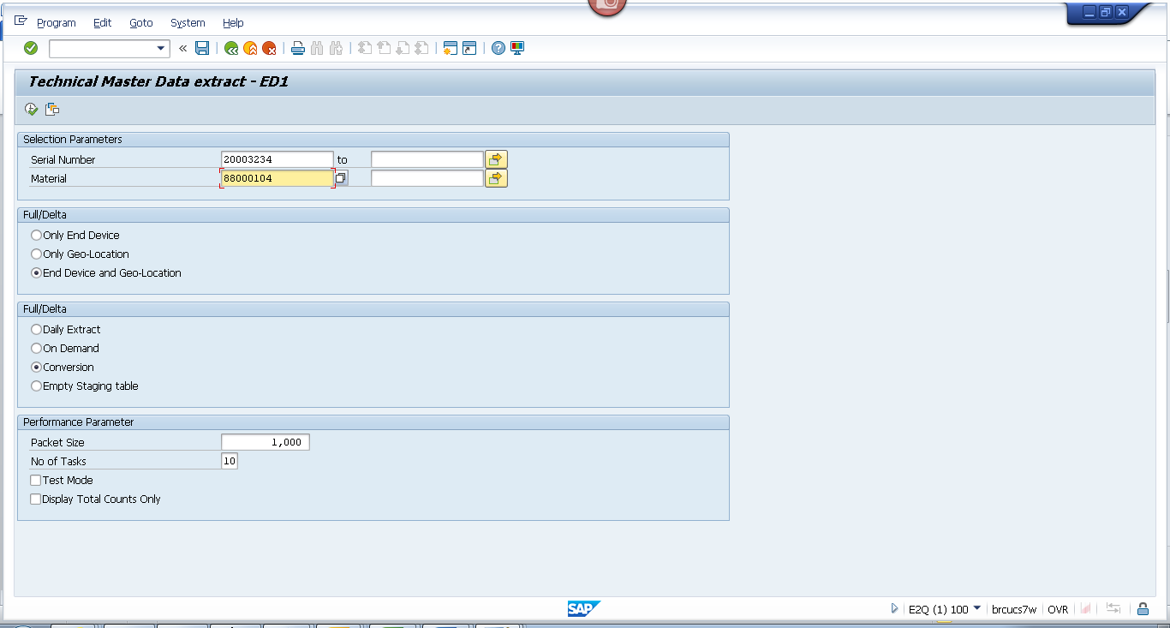
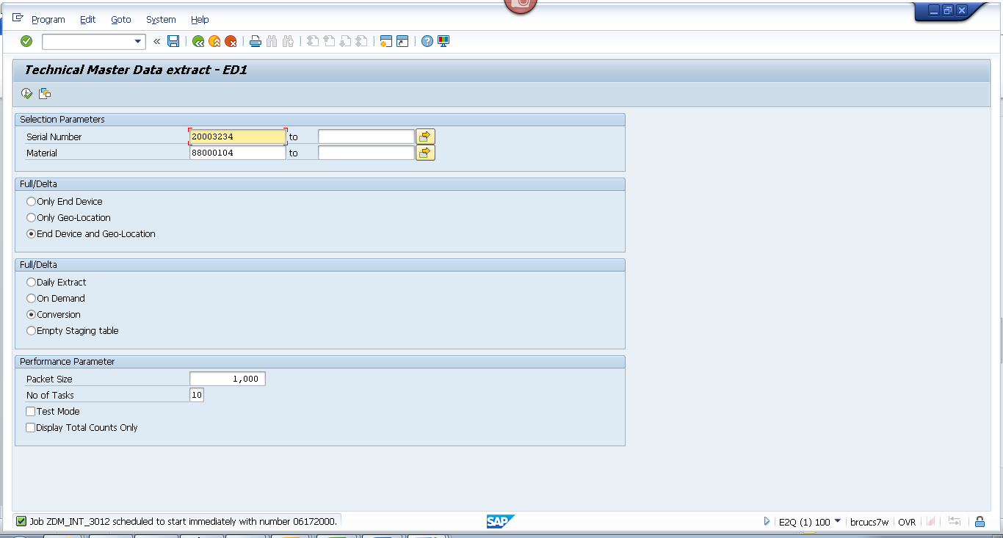

Obj tracking
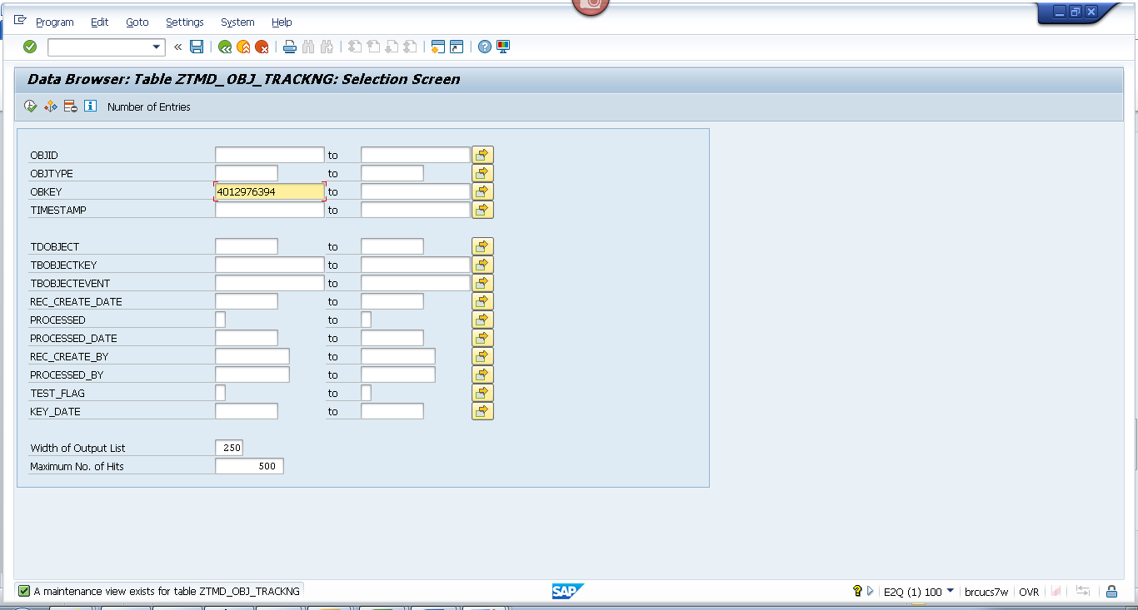
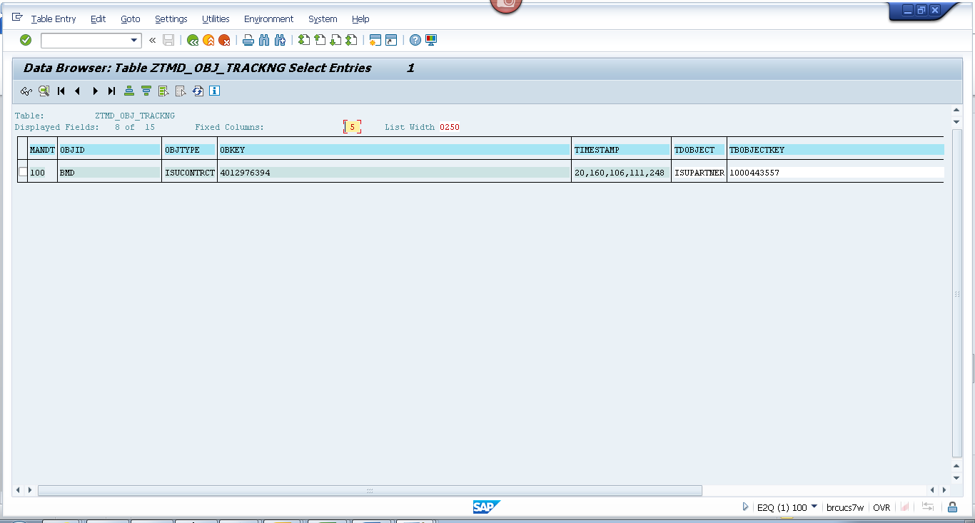
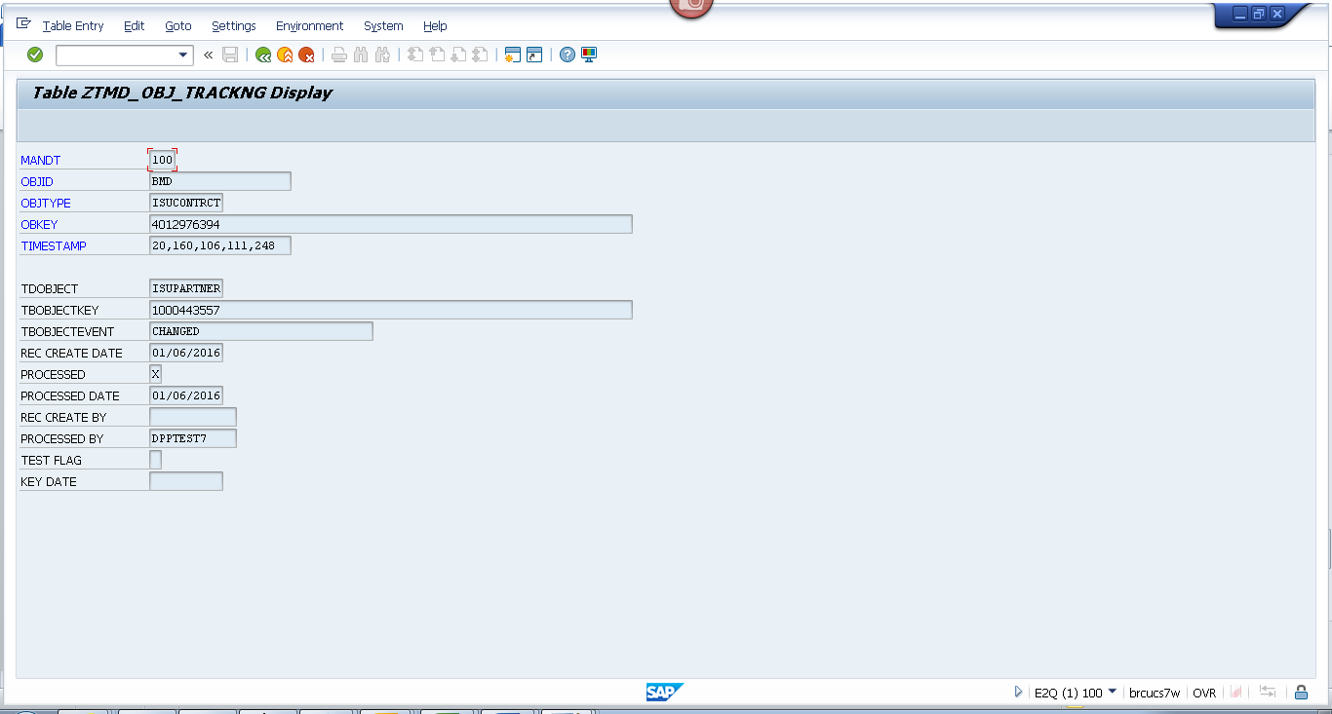

Spool
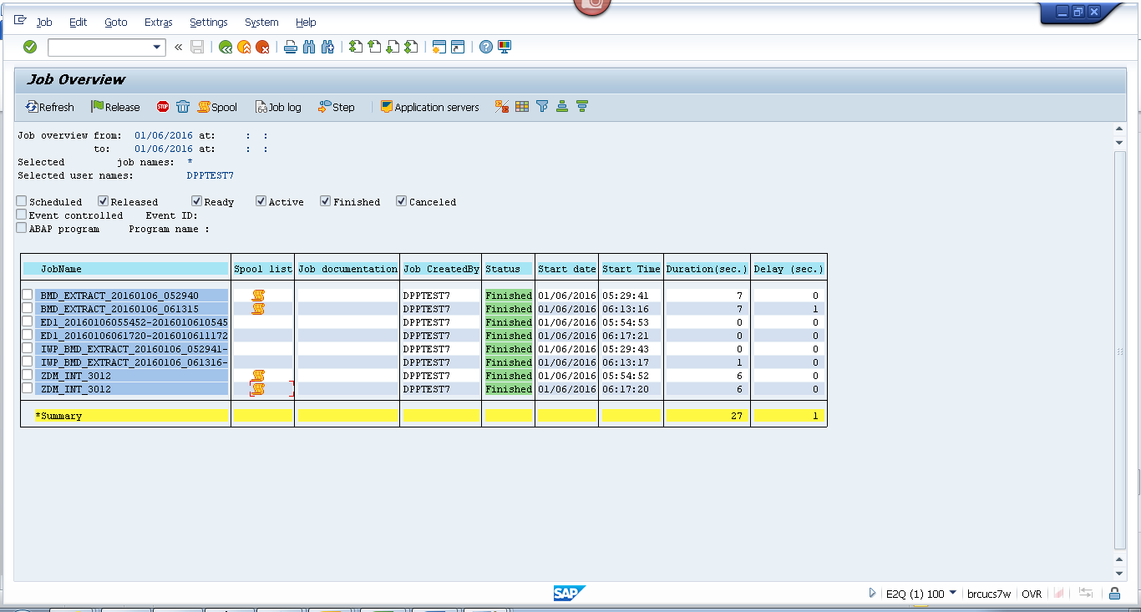
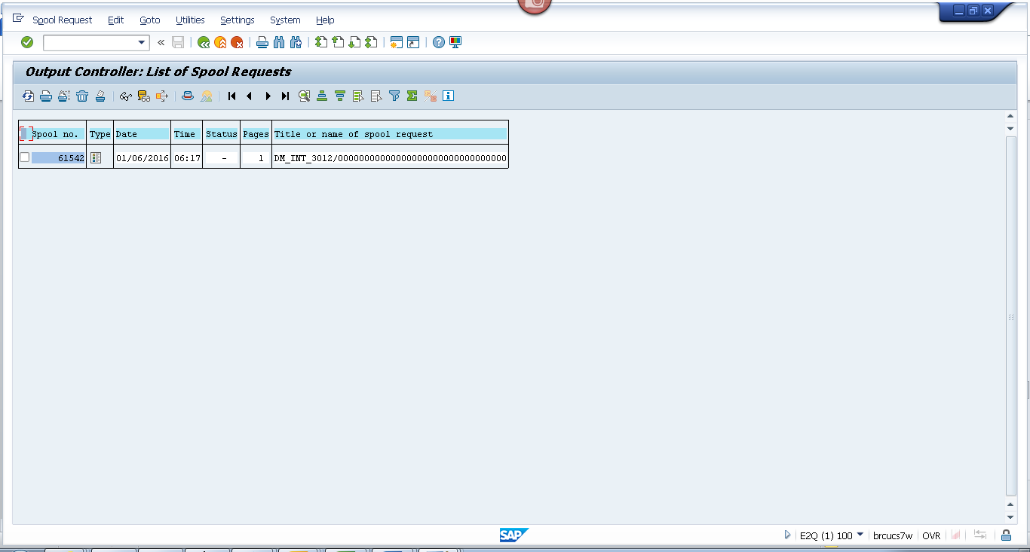
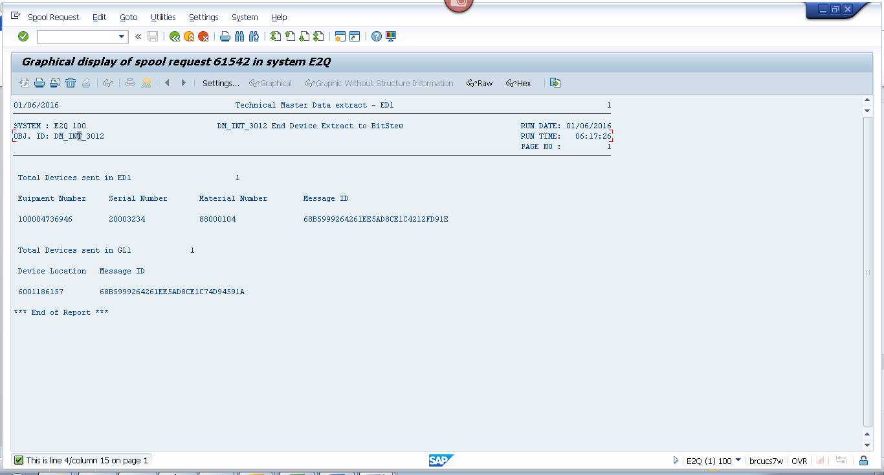

Payload

Geo loc
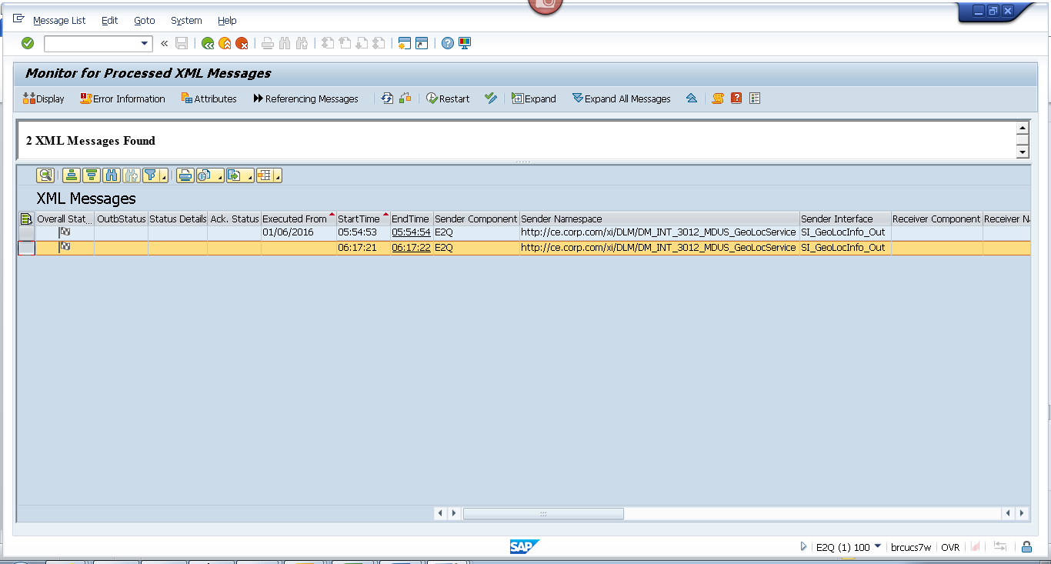
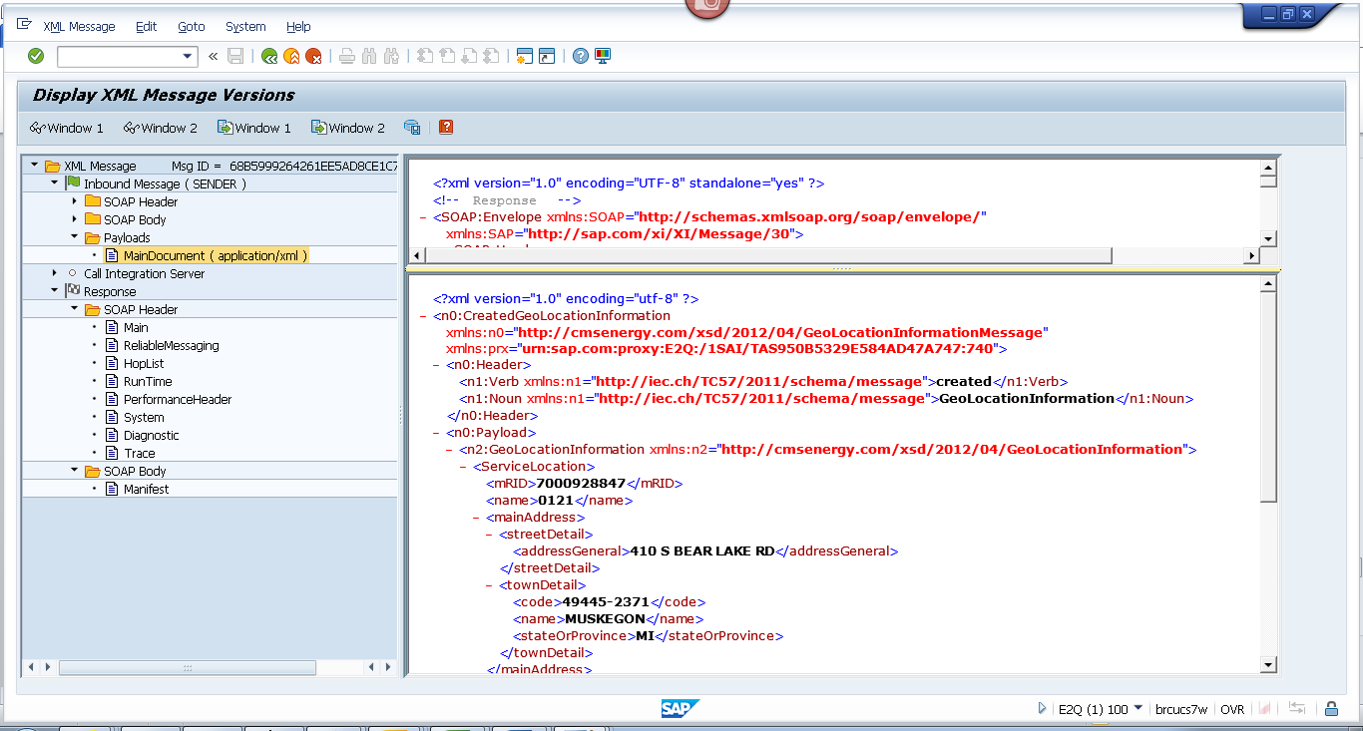
<?xml version="1.0" encoding="utf-8" ?>
- <n0:CreatedGeoLocationInformation xmlns:n0="http://cmsenergy.com/xsd/2012/04/GeoLocationInformationMessage" xmlns:prx="urn:sap.com:proxy:E2Q:/1SAI/TAS950B5329E584AD47A747:740">
- <n0:Header>
<n1:Verb xmlns:n1="http://iec.ch/TC57/2011/schema/message">created</n1:Verb>
<n1:Noun xmlns:n1="http://iec.ch/TC57/2011/schema/message">GeoLocationInformation</n1:Noun>
</n0:Header>
- <n0:Payload>
- <n2:GeoLocationInformation xmlns:n2="http://cmsenergy.com/xsd/2012/04/GeoLocationInformation">
- <ServiceLocation>
<mRID>7000928847</mRID>
<name>0121</name>
- <mainAddress>
- <streetDetail>
<addressGeneral>410 S BEAR LAKE RD</addressGeneral>
</streetDetail>
- <townDetail>
<code>49445-2371</code>
<name>MUSKEGON</name>
<stateOrProvince>MI</stateOrProvince>
</townDetail>
</mainAddress>
- <UsagePoints>
<mRID>6001186157</mRID>
<name>OUT LEFT</name>
- <EndDevices>
<mRID>CA-61-10172323-0105</mRID>
<type>T</type>
</EndDevices>
- <PositionPoint>
<xPosition>-86.186157</xPosition>
<yPosition>43.186157</yPosition>
</PositionPoint>
</UsagePoints>
</ServiceLocation>
</n2:GeoLocationInformation>
</n0:Payload>
</n0:CreatedGeoLocationInformation>

End Device
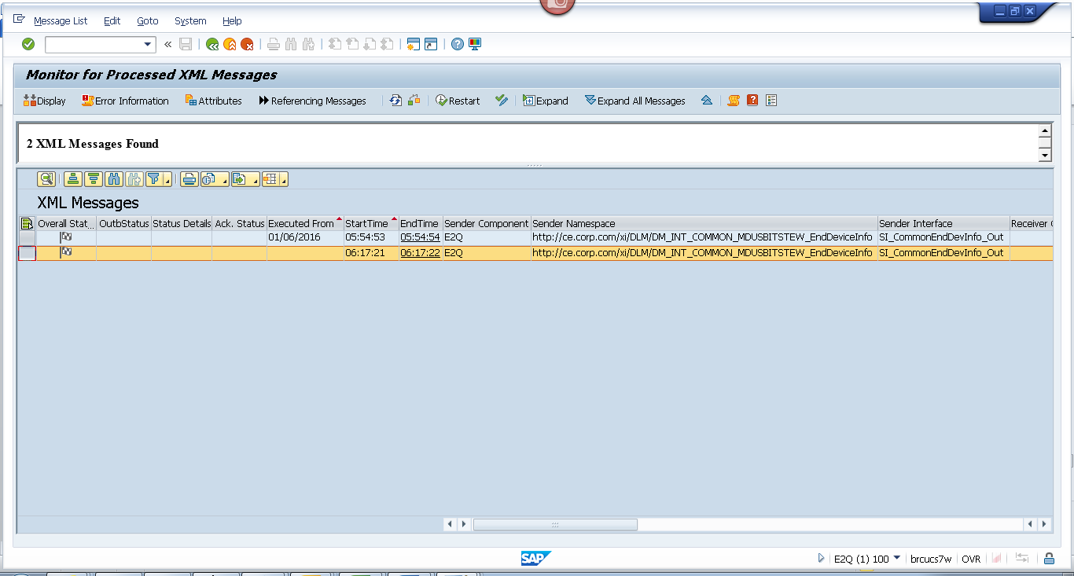
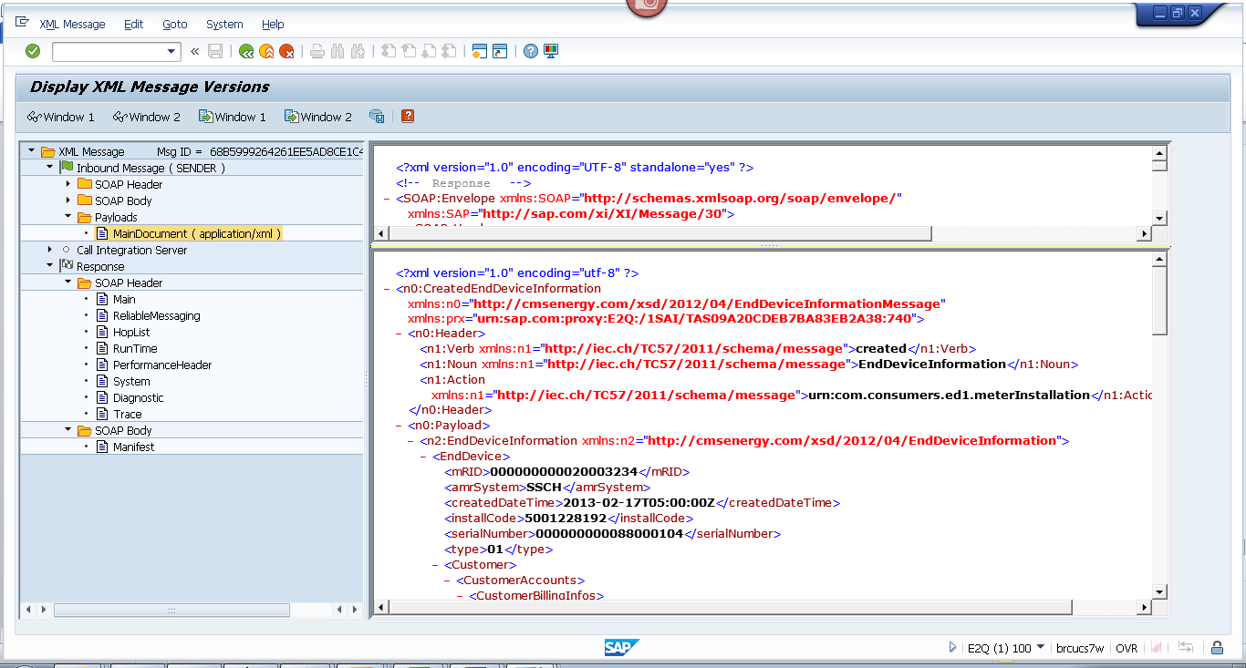
<?xml version="1.0" encoding="utf-8" ?>
- <n0:CreatedEndDeviceInformation xmlns:n0="http://cmsenergy.com/xsd/2012/04/EndDeviceInformationMessage" xmlns:prx="urn:sap.com:proxy:E2Q:/1SAI/TAS09A20CDEB7BA83EB2A38:740">
- <n0:Header>
<n1:Verb xmlns:n1="http://iec.ch/TC57/2011/schema/message">created</n1:Verb>
<n1:Noun xmlns:n1="http://iec.ch/TC57/2011/schema/message">EndDeviceInformation</n1:Noun>
<n1:Action xmlns:n1="http://iec.ch/TC57/2011/schema/message">urn:com.consumers.ed1.meterInstallation</n1:Action>
</n0:Header>
- <n0:Payload>
- <n2:EndDeviceInformation xmlns:n2="http://cmsenergy.com/xsd/2012/04/EndDeviceInformation">
- <EndDevice>
<mRID>000000000020003234</mRID>
<amrSystem>SSCH</amrSystem>
<createdDateTime>2013-02-17T05:00:00Z</createdDateTime>
<installCode>5001228192</installCode>
<serialNumber>000000000088000104</serialNumber>
<type>01</type>
- <Customer>
- <CustomerAccounts>
- <CustomerBillingInfos>
<mRID>RES</mRID>
<type>A_200</type>
<startDate>1900-01-01T05:00:00Z</startDate>
<endDate>2008-11-24T05:00:00Z</endDate>
<readRoute>041923</readRoute>
<readCycle>19</readCycle>
</CustomerBillingInfos>
- <CustomerBillingInfos>
<mRID>RES</mRID>
<type>RS_1000</type>
<startDate>2008-11-25T05:00:00Z</startDate>
<endDate>9999-12-31T05:00:00Z</endDate>
<readRoute>041923</readRoute>
<readCycle>19</readCycle>
</CustomerBillingInfos>
</CustomerAccounts>
</Customer>
- <EndDeviceFunction>
<mRID>000000100004736946</mRID>
<name>ESM 1PH 3W 200A 240V 2S SS RS/RT</name>
<programID>1NDRSRT001</programID>
</EndDeviceFunction>
- <UsagePoint>
<mRID>6001186157</mRID>
<name>OUT LEFT</name>
<phaseCode>A</phaseCode>
<readCycle>19</readCycle>
<readRoute>041923</readRoute>
- <Installation>
<mRID>5001228192</mRID>
</Installation>
- <MeterServiceWorks>
<type>MIV</type>
</MeterServiceWorks>
- <ServiceLocation>
<mRID>7000928847</mRID>
<name>0121</name>
- <mainAddress>
- <streetDetail>
<addressGeneral>410 S BEAR LAKE RD</addressGeneral>
</streetDetail>
- <townDetail>
<code>49445-2371</code>
<name>MUSKEGON</name>
<stateOrProvince>MI</stateOrProvince>
</townDetail>
</mainAddress>
</ServiceLocation>
</UsagePoint>
- <information>
<description>1002</description>
<title>AMCG</title>
</information>
- <status>
<reason>System Status</reason>
<value>Installed</value>
</status>
- <status>
<reason>User Status</reason>
<value>No Special test Available</value>
</status>
- <status>
<dateTime>2012-12-16T05:00:00Z</dateTime>
<reason>Cutover Date</reason>
</status>
- <status>
<dateTime>2012-12-15T05:00:00Z</dateTime>
<value>Install Date</value>
</status>
- <status>
<reason>Certification Year</reason>
<value>2012</value>
</status>
- <status>
<reason>Certification Status</reason>
<value>No restriction</value>
</status>
</EndDevice>
</n2:EndDeviceInformation>
</n0:Payload>
</n0:CreatedEndDeviceInformation>

